Web Designing Assignment

Term -1

Module (HTML)-1

* Are the HTML tags and elements the same thing?

Ans: HTML tags and elements are related but they are not same.

HTML tags are just opening and closing entity tags begin with < symbol and end with > symbol. Whatever written inside < and > are called as tags

Example: <Body></Body>

<p></p>

HTML elements enclose the content in between the tags. They define the some kind of expression. It generally consist of a start tag, content and an end tag.

Example: <b>This Is Home Page</>

* What are tags and attributes in HTML?

Ans: HTML tag is a way of representing an HTML element in the program,

While an attribute is a way of describing the characteristics of an HTML eliment.

Here most of tags and there attribute to use for formatting the HTML.

**Codes**

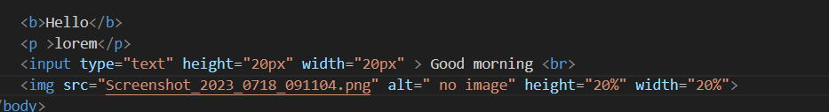

**Output**

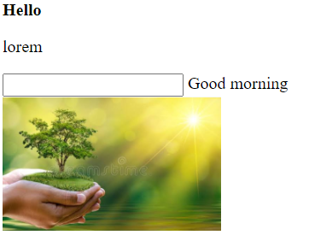

* What are void elements in HTML?

Ans: Most of the HTML elements have start with tags and ends with tag

But some elements are start with tags but end without tags these elements called void element.

**Code**

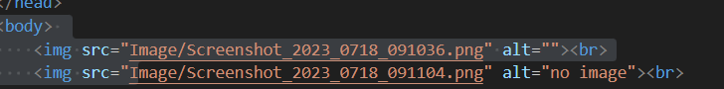

**Output**



* What are HTML Entities?

Ans: HTML entities are the reserved characters that have special meaning when used in an HTML document. Each of these codes starts with an ampersand and ends with a semicolon.

**Code:**

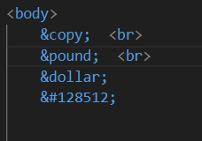

**Output:**

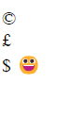

* What are different types of lists in HTML?

Ans: There are three types of lists in HTML.

1. Unordered list (ul)
2. Ordered list (ol)
3. Description list (dl)

***Code***

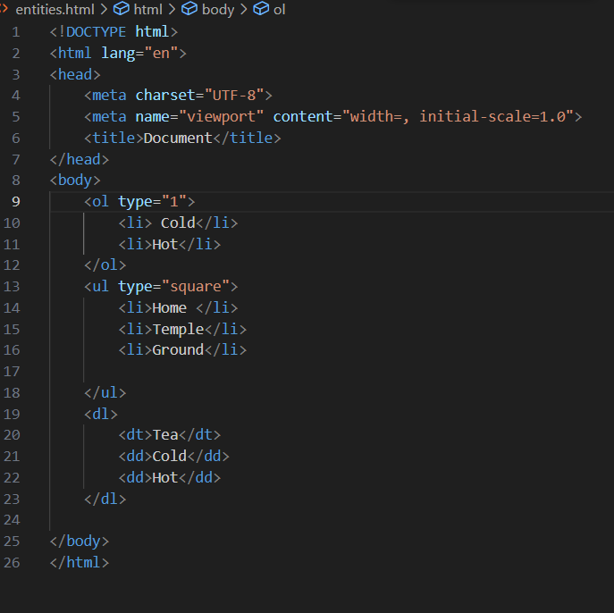

***Output***

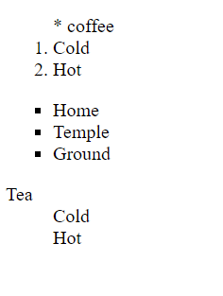

* What is the ‘class’ attribute in HTML?

Ans: The class is an attribute that specifies one or more class names for an HTML element.

The class attribute is use any HTML element.

The class name use by CSS and JavaScript to perform certain tasks for element with the specified class name.

**Code**

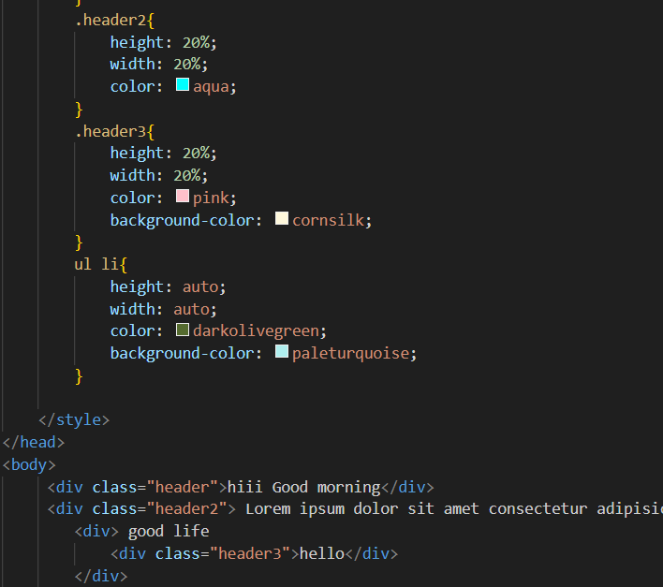

**Output**



* What is the difference between the ‘id’ attribute and the ‘class’ attribute of HTML elements?

Ans: The ‘id’ attribute is special attribute this can apply to at most one element ,

While the ‘class’ selector can apply to multiple elements.

The id attribute is a unique identifier that is used to specify the document. It is used by CSS and JavaScript to perform certain task for a unique element.

The class attribute is used to specify one or more class names for an HTML element. The class attribute can be used on any HTML element

**Code**

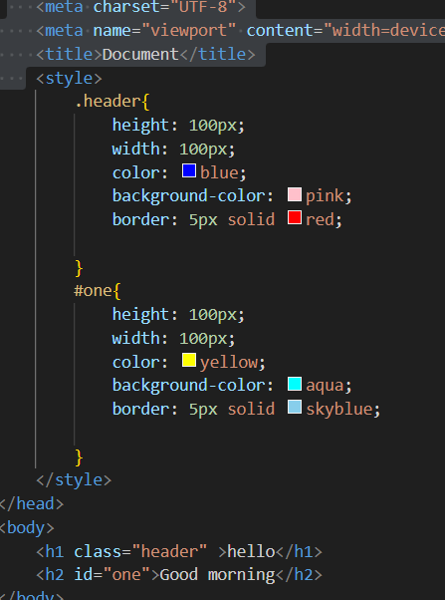

**Output**

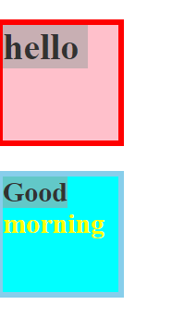

* What are the various formatting tags in HTML?

Ans: HTML provides many predefined elements that are used to change the formatting of text. The formatting can be used to set the text style (Like – Bold, Italic, emphasized, etc.), highlight the text, Make a text superscript and subscript, etc.

**Code**

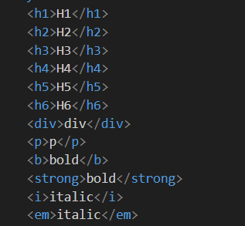

**Output**

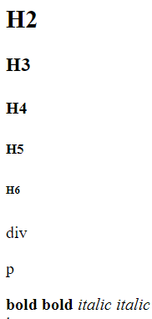

* How is Cell Padding different from Cell Spacing?

Ans: Cellpadding specifies the space between the border of the table cell and its contents it defines the whitespaces between the cell edge and the content of the cell.

**Code:**

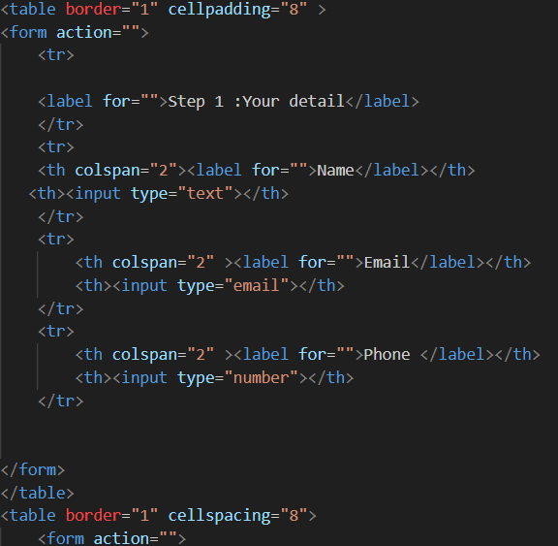

**Output:**

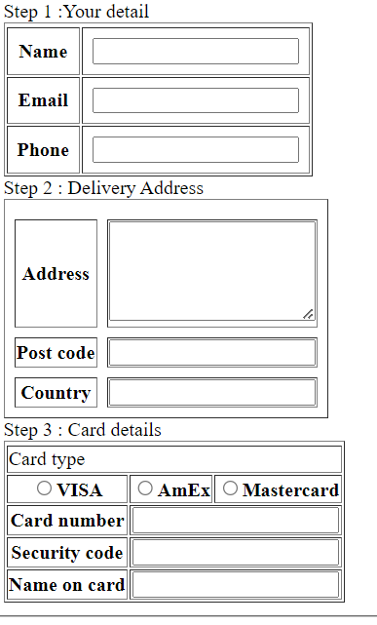

* How can we club two or more rows or columns into a single row or column in an HTML table?

Ans: We use the colspan and rowspan attribute, to merge cells in HTML. The rowspan attribute is for the number of rows a cell should merge, whereas the colspan attribute is for the number of columns a cell should merge. The attribute should be placed inside the <td> tag.

**Code:**

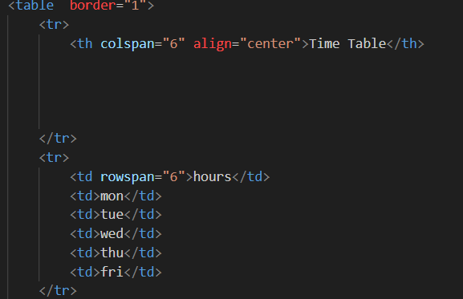

**Output**

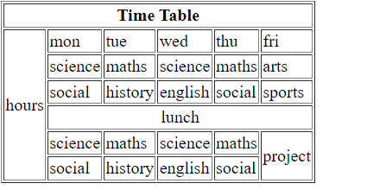

* What is the difference between a block-level element and an inline element?

Ans: **lock elements:**They consume the entire width available irrespective of their sufficiency. They always start in a new line and have top and bottom margins. It does not contain any other elements next to it.

**Code**

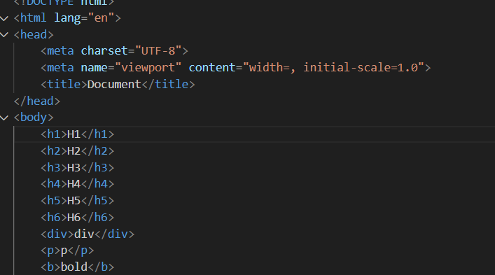

**Output**

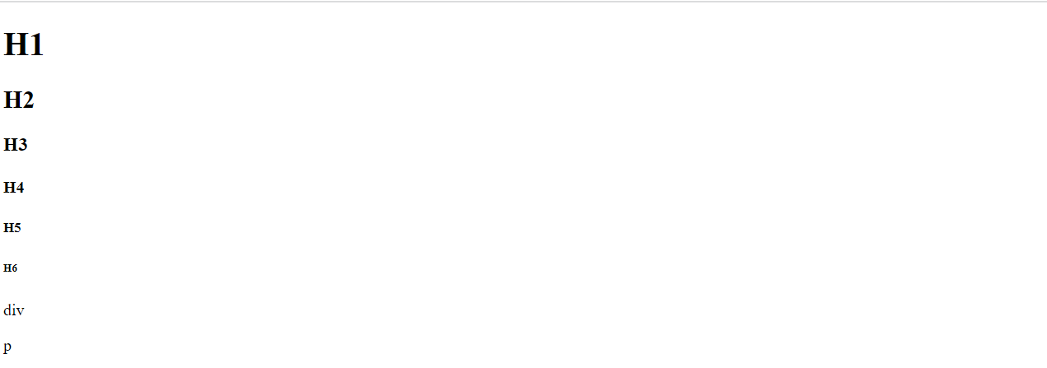

 **Inline elements:**Inline elements occupy only enough width that is sufficient to it and allows other elements next to it which are inline. Inline elements don’t start from a new line and don’t have top and bottom margins as block elements have.

**Code:**

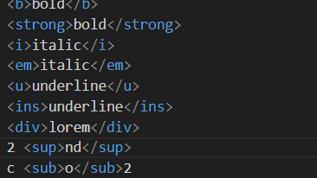

**Output:**

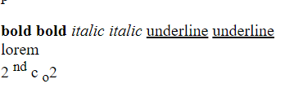

* How to create a Hyperlink in HTML?

**Ans:**

**code:**

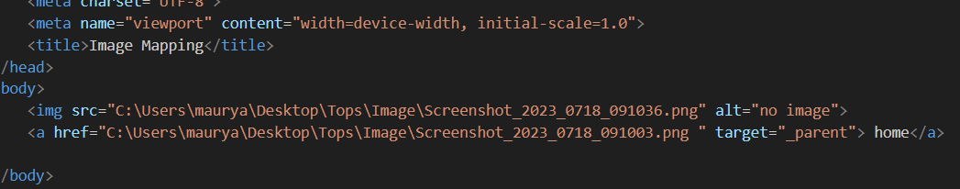

**Output:**



* What is the use of an iframe tag?

Ans: The iframe in HTML stands for **Inline Frame**. The ” iframe ” tag defines a rectangular region within the document in which the browser can display a separate document, including scrollbars and borders. An inline frame is used to embed another document within the current HTML document.

**Code**

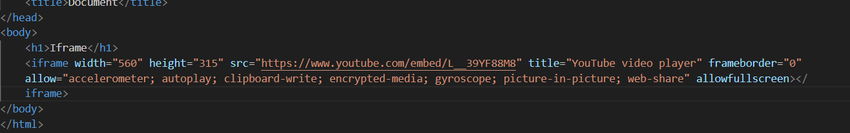

**Output**



* What is the use of a span tag? Explain with example?

Ans: The span tag is an inline container used to mark up a part of a text, or a part of a document. The HTML span element is a generic inline container for inline elements and content. It is used to group elements for styling purpose , a better way to use it when no other semantic element is available.

* How to insert a picture into a background image of a web page?

Ans:

**Code:**

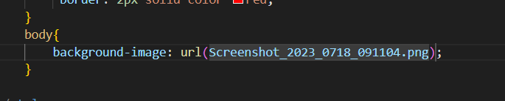

**Output**



* How are active links different from normal links?

Ans: Normal and Active links are pretty much the same which one basic different between them. it is normal link is just a line of code a containing a pointer to another resources. Active link is also a line of code pointing to another resources but, it is in the action of opening the resources being pointed.

* What are the different tags to separate sections of text?

Ans: There are many tags in HTML to separate section of text defines the section of document such as chapters, header, footers, or any other section. The section tag divides the content into section and subsection.

Example:

<br>Tag = It is used to separate the line of text. Its breaks the current line and shifts the flow of the next line or a new line.

<p> Tag = This tag is used to write a paragraph of text.

* What is SVG?

Ans: SVG stands for scalable vector Graphics

* What is difference between HTML and XHTML?

Ans: HTML stands for Hypertext Markup Language, whereas XHTML stands for Extensible Hypertext Markup Language.

XHTML was developed to make HTML more extensible and flexible to work with other data formats.

* What are logical and physical tags in HTML?

Ans: Physical and Logical tags are used in HTML for better visibility and understanding of the text bye the user on the web page. However, both tags differ from each other as suggested by their names.

Physical tag: these tags are used to provide the visual appearance to the text.

Logical tag: These tags are used to add some logical or semantic value to the text.